**Node JS with Databases**

**Node JS with MySQL Database**

So first we have to install the mysql module using the npm commands.

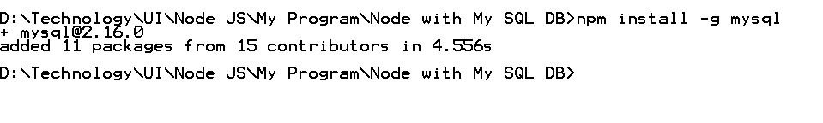

Now we will see how to connect the MySQL database using node js.

**databaseConnect.ts**

**const mysql = require("mysql");**

**const con = mysql.createConnection({**

**host:"localhost",**

**user:"root",**

**password:"root",**

**database:"test"**

**})**

**con.connect(function(err){**

**if(err) throw ex;**

**console.log("Connected...")**

**})**

**con.end();**

After run this program

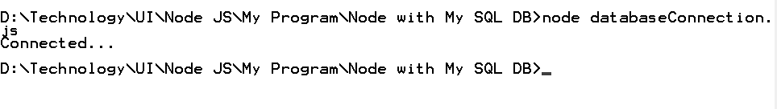

**CreateDatabase.ts**

**const mysql = require("mysql");**

**const con = mysql.createConnection({**

**host:'localhost',**

**user:'root',**

**password:'root'**

**});**

**con.connect(function(err){**

**if(err) throw ex;**

**console.log("Database connected");**

**});**

**let db = "create database mydb4;";**

**con.query(db,function(err,result){**

**if(err){**

**console.log(err);**

**}else{**

**console.log("Database created ");**

**}**

**});**

**con.end();**

**Insert Query using Node js**

**var mysql = require('mysql');**

**var con = mysql.createConnection({**

**host:'localhost',**

**user:'root',**

**password:'root',**

**database:'test'**

**});**

**con.connect(function(err){**

**if(err){**

**console.log('Error genered'+err)**

**}else {**

**console.log('Connected successfully');**

**}**

**})**

**//Static values**

**/*var res =con.query("insert into employee values(9,'Amar',19000)",function(err,result){**

**if(err){**

**console.log(err.message)**

**}else {**

**console.log(result.affectedRows)**

**}**

**});*/**

**//Storing the values**

**var res =con.query("insert into employee values(?,?,?)",[102,'Rahul',160000],function(err,result){**

**if(err){**

**console.log(err.message)**

**}else {**

**console.log(result.affectedRows)**

**}**

**});**

**console.log('Result '+res.count)**

**//Emp object passing**

**/*let emp= {"id":3,"name":"Ravi","salary":14000};**

**var res =con.query("insert into employee set ?",emp,function(err,result){**

**if(err){**

**console.log(err.message)**

**}else {**

**console.log(result.affectedRows)**

**}**

**});**

**console.log('Result '+res.count)*/**

**con.end();**

**Delete query using node js**

**var mysql = require('mysql');**

**var con = mysql.createConnection({**

**host:'localhost',**

**user:'root',**

**password:'root',**

**database:'test'**

**});**

**con.connect(function(err){**

**if(err){**

**console.log('Error genered'+err)**

**}else {**

**console.log('Connected successfully');**

**}**

**})**

**var res =con.query("delete from employee where id=?",[101],function(err,result){**

**if(err){**

**console.log(err.message)**

**}else {**

**if(result.affectedRows>0){**

**console.log("Record deleted successfully!");**

**}else {**

**console.log("Record is not present");**

**}**

**}**

**});**

**con.end();**

**update query using node js**

**var mysql = require('mysql');**

**var con = mysql.createConnection({**

**host:'localhost',**

**user:'root',**

**password:'root',**

**database:'test'**

**});**

**con.connect(function(err){**

**if(err){**

**console.log('Error genered'+err)**

**}else {**

**console.log('Connected successfully');**

**}**

**})**

**var res =con.query("update employee set salary =? where id =?",[35000,102],function(err,result){**

**if(err){**

**console.log(err.message)**

**}else {**

**if(result.affectedRows>0){**

**console.log("Record updated successfully!");**

**}else {**

**console.log("Record is not present");**

**}**

**}**

**});**

**con.end();**

**Retrieve the records using the node js**

**var mysql = require('mysql');**

**var con = mysql.createConnection({**

**host:'localhost',**

**user:'root',**

**password:'root',**

**database:'test'**

**});**

**con.connect(function(err){**

**if(err){**

**console.log('Error genered'+err)**

**}else {**

**console.log('Connected successfully');**

**}**

**});**

**var sql="select * from employee"**

**con.query(sql, function(error, results) {**

**if (error) {**

**return console.error(error.message);**

**}**

**console.log(results);**

**results.forEach(element => {**

**console.log("Id is "+element.id+" Name is "+element.name+" Salary is "+element.salary);**

**});**

**});**

**con.end();**